ChassisSim Excel setup sheet Documentation

Introduction

The purpose of this document is to outline the mechanics of running and setting up the ChassisSim Excel document that has a simplified ChassisSim interface.

The mechanics of the interface will be discussed as well as what is required to set it up.

Setup

To setup this example of the ChassisSim setup service is very simple. This is what needs to be done

1) Go to C:\ChassisSim Technologies and create a folder called Models in this directory
2) Go to the help directory in the ChassisSim install. Under Excel Resources you'll find a zip file called Dal F310.zip. Extract this to C:\ Drive.
3) Copy the folder called Dal F310 and put it in C:\ChassisSim Technologies\Models
4) Create a folder called C:\ChassisSimTechnologies
5) Put the excel document CSim_setup_service_v2.xls any where you want.

You should now be good to go.

Navigating the environment

The ChassisSim Excel sheet features a greatly simplified user interface with fixed choices of setup options and tracks and data logging options.

The setup manipulation is done on the Setup sheet. A screen shot of this is shown below

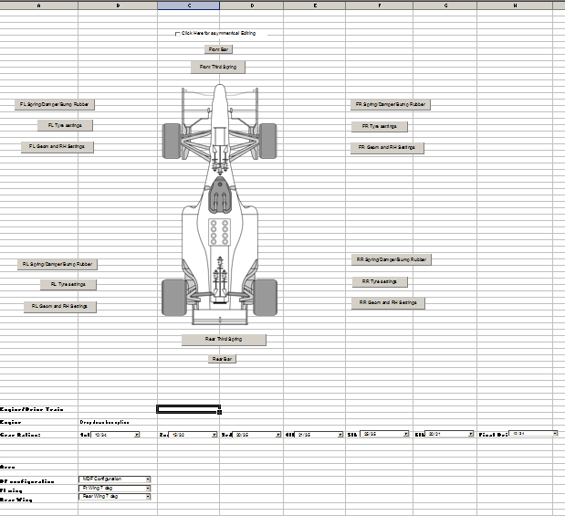
Fig - 1 - Setup sheet of the ChassisSim excel sheet
As can be seen there are dialogs that handle spring selection, tyre settings and suspension geometry sections. This allows the user to select from a list of pre determined options. An illustration of this is the spring dialog. This is shown below,

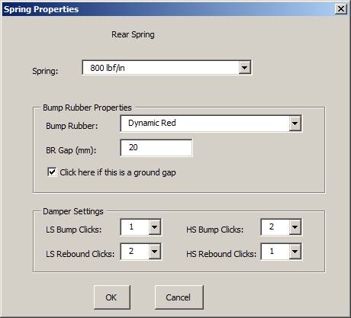

Fig - 2 - Spring options dialog

This also goes for the gear and wing options dialog where the user selects from a list of pre-determined options.

In terms of running the simulation this is done in the Simulation tab. This is shown in Fig - 3 ,
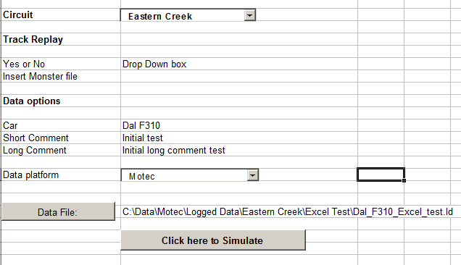

Fig - 3 - Simulation sheet page

As can be seen the end user selects the circuit and the data logging options. To simulate the user selects the Simulate button and ChassisSim is called externally.

Setting up the ChassisSim excel document

Setup Files and Directories

The core of what makes the ChassisSim excel setup document works and be association the ChassisSim is setup files. These are ascii files that describe spring, suspension geometry, kinematics and aero behaviour. The components for this are described in detail in the document CSim_setup_File_import.doc in the ChassisSim help manual.

In order to organise this the ChassisSim setup service assumes a set directory structure. The models need to be located in the C:\ChassisSim Technologies\Models\CarName. Under this global directories this is how the car components are stored,

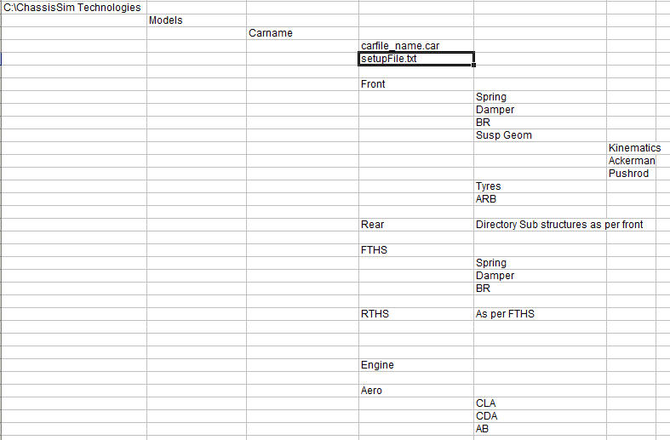

Fig - 4 - ChassisSim excel setup directory.

As can be seen from Fig 4 the relevant files go in the relevant directories. The spring files go in the spring directory, the ARB files go in the ARB folder. For the suspension folder the pickup points go into kinematics, Ackerman goes into Ackerman and the Pushrod folder. The Rear folder is a duplicate of the front.

Setting up executables and directories

In order to function correctly ChassisSim needs to know where the executables and directories are located. This is handled in the sheet File Locations. A screen grab of this is shown below,

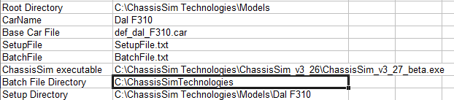

Fig - 5: Setting up file locations

The function of these tables are outlined below,

Table 1 - Function of ChassisSim input files

Item | Description
Root Directory | This is the base directory that will be referred by the scripting
CarName | This is the CarName as seen in Fig-4
Base Car File | This is the basis of the Car file
SetupFile | This is the setup file created when you run a simulation
BatchFile | This is the batch file created when you run a simulation
ChassisSim executable | Path to the ChassisSim executable
Batch File Directory | This is where the batch file is located. Please ensure there are no spaces in this file name
Setup Directory | Area of future development.

Please note all of these must be filled in correctly for this to function directly.

Spring Setup Page

The Spring Setup Page contains the current settings, names and file locations for the springs. This is shown below,

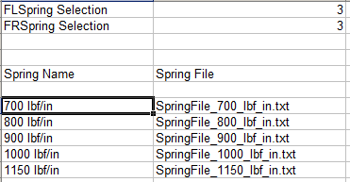
The top 2 entries are are a 0 based index for the spring selection entities. In terms of the spring information the Spring Name populates the combo box entries. The Spring File populates the available files. Note the Spring Names are stored in the Lists FtSpringTitle and RearSpringTitle in the excel document. Please note this is the same structure front and rear.

Bump Rubber selection sheet

The Bump Rubber selection sheet is shown below,

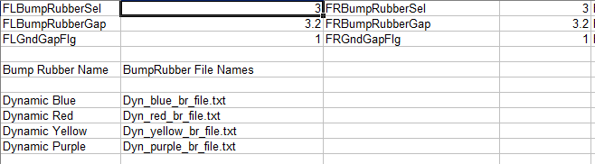

The bump rubber selection is based on a zero based index which is stored in the first row. The second row stores the packer gap in mm and the third row indicates whether it is a ground gap (1) or an air gap (0).

The Bump rubber name stores the names used in the combo boxes while the Bump rubber File names store the file names used to define the bump rubber. The list for the bump rubber names are stored in the list names FTBRTitle (Front bump rubbers) and RearBRTitle (Rear springs)

Damper setup sheet

The damper setup sheet stores the total no of damper settings in low and high speed bump and rebound. It also stores the current settings as well as the filenames. The setup page is illustrated below,
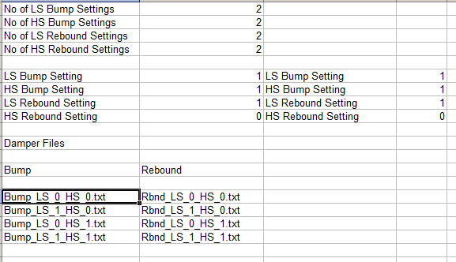

Please note in the setup page for the dampers the end user selects the damper setting on a 1 based index, with 1 being softest and the number specified in the first 4 rows being the upper end. Please note though in the damper sheet a zero based index is used.

The damper files use the seperate bump and rebound file definitions for dampers for the ChassisSim scripting. This is why you have separate files for bump and rebound. The indexing for this is given by the following formula,

cur_index = LS_setting + Max_No_LS_setting*HS_setting

Where,

cur_index = The current 0 based index
LS_setting = Current 0 based low speed index
Max_No_LS_setting = Maximum no of Low speed settings
HS_setting = Current 0 based high speed index.

The file that will be used is given by the base file index (in the above example the index of Bump_LS_0_HS_0.txt) added to the current index given in the formula above.

Roll Bar Page

The Roll Bar Page is illustrated below,

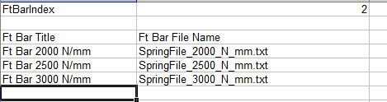

The bar selection is stored as a zero index. The Bar title which populates the combo box is stored in the first column. The spring file names are stored in the second column. The bar list names in the excel document are stored in the names FtBarTitle for the front and RearBarTitle for the rear.

The file that is used is the base index of the first file plus what ever the Bar Index is.

Geometry sheet

The Geometry sheet is listed below,

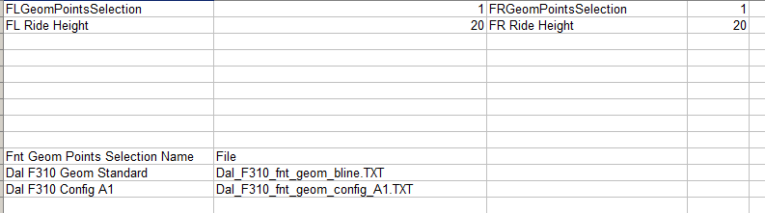

The current kinematic selection is stored as a 0 based index in the first row. The ride height is stored in mm. The Geometry names are stored in the first column and the filenames are stored in the second column. The list names in the Excel document are FtGeomPointsTile for the front and RearGeomPointsTitle for the rear.

Gear Setup Page

The Gear setup page is shown below,

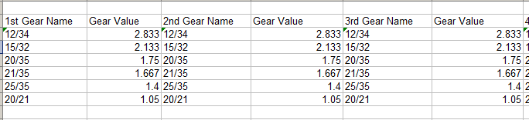

The structure is the list name and then the value of the gear is stored as a torque multiplier. The listing for the gear names are Gear1stTitle for first gear and so on for the number of gears. The final gear title is GearFinalTitle.

Aero Setup Page

The aero Setup Page is shown below,

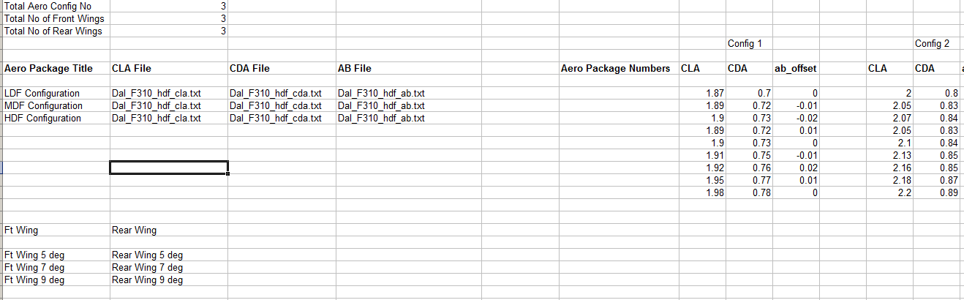

The total no of aero configurations and front and rear wings is shown in the second column.

The CLA and CDA and aero balance files are shown in the relevant LDF, MDF and HDF configuration packages. Please note the aero balance has the entries in the map as %age/100.

The list of available Wings are shown in the Front and Rear Wing lists as shown below. They are stored in the excel list as FtWingTitle and RearWingTitle for the rear.

Lastly the List of max CLA and CDA and aero balance offset are stored in the Configuration paramaters. These are stored in ascending order of fixed front wing with the rear wing increasing. The CLA, CDA and aero balance numbers that will be assigned will be given by this index,

cur_index = RearWing_setting + Max_No_RearWings*FtWing_setting

Where,

cur_index = The current 0 based index
RearWing_setting = Current 0 Rear Wing setting
FtWing_setting = Current 0 based Ft wing setting
Max_No_RearWings = Maximum no of rear wings.

Circuit Setup Page

The circuit setup page is shown below

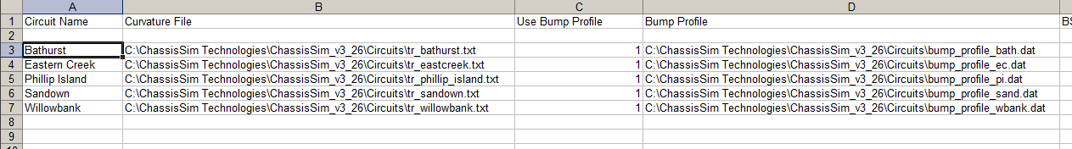

The circuit list is stored in the first column as Illustrated and stored in the list CircuitTitle. The Curvature file and Bump profile are stored in columns as illustrated.

